**ALARM SOUND WHEN TEMPERATURE IS HIGH**

**ASSIGNMENT-II**

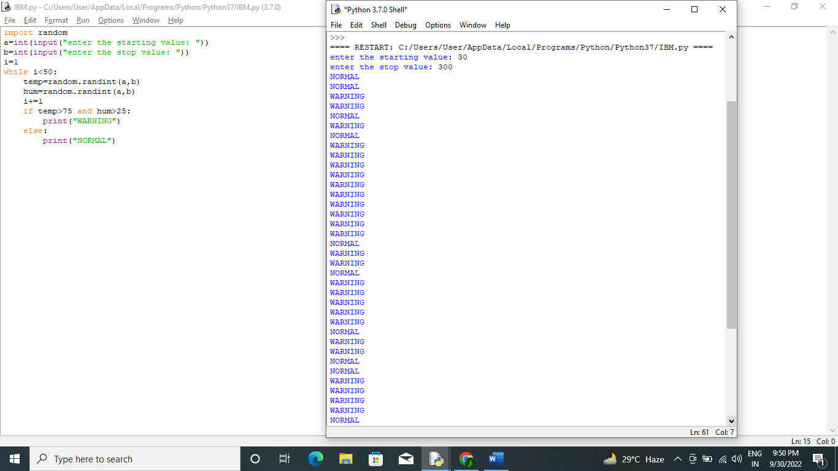

**PROGRAM:**

import random

a=int(input("enter the starting value: "))

b=int(input("enter the stop value: "))

i=1

while i<50:

temp=random.randint(a,b)

hum=random.randint(a,b)

i+=1

if temp>75 and hum>25:

print("WARNING")

else: print("NORMAL")